Potential Divider Circuits:
A potential divider is a simple circuit which uses resistors (as well as LDR’s and thermistors) to supply a variable potential difference (or output voltage).
Some of these circuits have just fixed resistors – in this instance, the output voltage is a fixed proportion to the supply voltage; it’s a bit like ratios. If your R₁ and R₂ values are the same, then the output value will be half of the input voltage – you’ll understand why when you see the equation below.
Some of these circuits have one variable resistor and one fixed resistor – the output voltage can be altered using this.

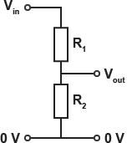

Calculating Output Voltage:
V_{OUT} = V_{IN} x (R₂ / R₁ + R₂)
When your R₂ value is much greater than your R₁ value, the output voltage will be approximately the same as the input voltage.
When your R₂ value is much less than your R₁ value, the output voltage will be approximately zero.
Some electrical components will only start working at a threshold voltage – when you use a variable resistor as part of a potential divider, you can set this threshold voltage.
Resistors in parallel:
We can arrange resistors in parallel and this will decrease the total resistance; the equation to work out total resistance is shown below:
1/R_{T} = 1/ R₁ + 1/ R₂ + 1 / R₃
LDR’s and Thermistors:
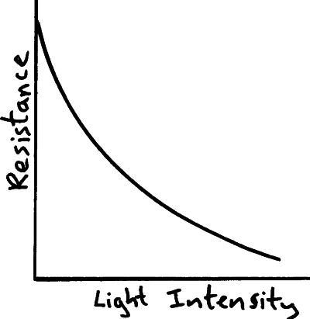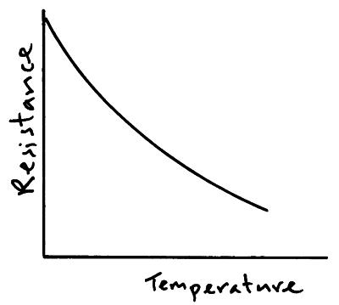
The resistance of an LDR decreases as light intensity increases.
The resistance of a thermistor decreases as temperature increases.

Uses of Potential Divider Circuits:
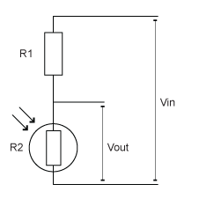
Street lights use LDR’s in potential divider circuits - this is placed in the R₂ position (as seen to the left).
When it’s bright, the resistance of the LDR (R₂) is very low. The R₁ fixed resistor is made to have a higher resistance than the LDR – this will mean that the output voltage will be very low and the street light will NOT be on.
When it gets dark, the resistance of the LDR will increase. It will increase so that it is more than the R₁ value. This will mean that the output voltage will increase, and the street light will turn on.
A thermistor can be used to switch on a heater when the temperature falls too much in a home – it uses the above principal.

Past Papers:
PPQ(1):
PPQ(2):
PPQ(3):
Continued on next page...

PPQ(4):
PPQ(5):
PPQ(6):
Mark Schemes:
PPQ(1):
PPQ(2):
PPQ(3):
PPQ(4):
PPQ(5):
PPQ(6):

