Resistance and Current:
Higher resistance means lower current (flow of electrons).
The higher the current, the brighter the bulb is in the circuit.
The higher the current, the faster a motor turns.
NOTE – voltage is needed to make the current flow through a circuit – it pushes the current along (as seen to the left).
Resistance (R) = Voltage (V) / Current (I)
R = Ohms, V = Volts, I = Amps
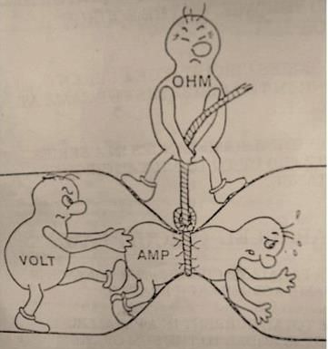
What affects resistance?
The resistance of a wire is dependent upon its length.
A variable resistor (symbol to the left) works by changing the lengths of wire in the circuit; the longer the wire, the greater the resistance.
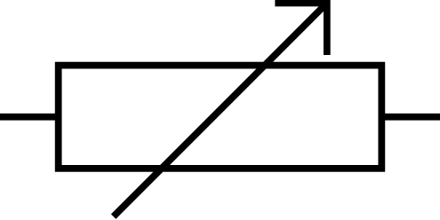
Ohmic and Non-Ohmic Devices:
Ohm’s law is the idea that the current travelling through something is directly proportional to the voltage across it; if you double the voltage, then the current will also double.
Resistors, at a constant temperature, follow Ohm’s law – the graph is a straight line passing through the origin.
The steeper the gradient of the graph (left), the greater the resistance – this is because if the gradient is steeper, the current will be less and the voltage more.
The same graph for a bulb will NOT be a straight line passing through the origin. The gradient of the line increases as current increases (it curves positively) – it does NOT follow Ohm’s Law.

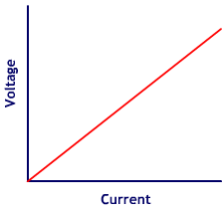

The resistance of a filament lamp increases as current increases.
When electrons collide with the filament (a thread-like fibre), it makes the atoms vibrate more. The increased vibration means two things:
- An increased number of collisions, which leads to more resistance
- An increase in the temperature of the filament
In a fixed resistor, the gradient of the graph is equal to the resistance.
The gradient of a voltage-current graph for a filament bulb will increase as resistance increases. To find the resistance, instantaneous results from the graph must be used.
A non-Ohmic device shows a curve with an increasing gradient, which means an increased resistance.
If the voltage supplied across a non-Ohmic device is increased, the electrons carry more energy. When these electrons collide with the metal atoms in the conductor, more energy is transferred and this increases the resistance and the temperature (this can be seen to the left).
NOTE – the cause of electrical resistance is the electrons (charge carriers) colliding with the metal atoms as they flow through a metal conductor, like a wire.
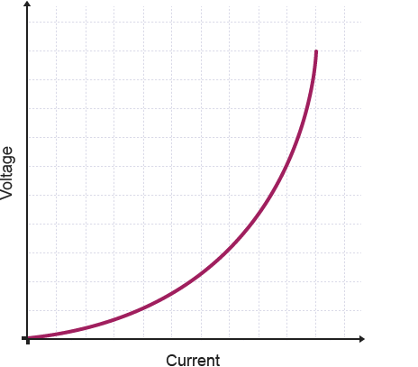

Past Papers:
PPQ(1):
Continued on next page...
PPQ(2):
Continued on next page...

(This circuit had a bulb)
Continued on next page...

PPQ(3):

PPQ(4):
PPQ(5):

Mark Schemes:
PPQ(1):
PPQ(2):
PPQ(3):
PPQ(4):
PPQ(5):

