P6 – Electricity for gadgets
Module Summary
Resistance
A variable resistor can be used to change the current in a circuit. The resistance is changed by having a different length of the variable resistor in the circuit. The longer the length the greater the resistance.
The greater the resistance the smaller the current in a circuit. A variable resistor can be used to control the current in a circuit, alter the brightness of a lamp or change the speed of a motor.
Resitance = $\frac{voltage}{ current}$
resistance is measured in ohms (Ω), current is measured in amps (A) and voltage is measured in volts (V)
In an Ohmic conductor (one that obeys ohms Law) the current increases as the voltage increases.
The gradient of a voltage current graph is equal to the resistance
V

I
When a wire gets hot its resistance increases. This means the shape of a voltage current graph for a lamp looks like:
V

I

The resistance of an LDR decreases with Light intensity
The resistance of a thermistor decreases as the temperature increases.

Two resistors can be used to form a potential divider circuit
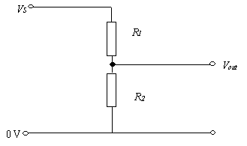
V _{out} = V _{in} X R₂ / (R₁ + R₂ )
By using an LDR or a thermistor alongside a fixed resistor, potential divider circuits can be used for circuits which depend on light or temperature conditions.

Electromagnetism
A current carrying conductor has a magnetic field around it.
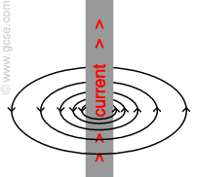
When a current carrying conductor is placed in a magnetic field produced by a permanent magnet, there if a force acting on it which moves the conductor. The direction of the force can be found from Flemings left hand rule.
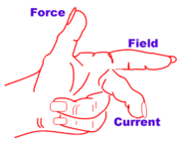
Fleming's left hand rule shows the direction of the force upon a current carrying wire when placed inside a magnetic field. This rule uses the thumb, and first two fingers of the left hand. The thumb acts as the thrust, the first finger is the field and the second finger acts as the current direction.

Motors use this force to change electrical energy into motion.
A simple d.c. electric motor can be built using a coil of wire that is free to rotate between two opposite magnetic poles. When an electric current flows through the coil, the coil experiences a force and moves.
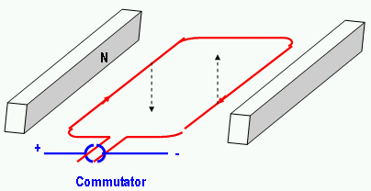
The direction of the current must be reversed every half turn, otherwise the coil comes to a halt again. This is achieved using a conducting ring split in two, called a split ring commutator. A coil of wire is used with lots of turns to increase the effect of the magnetic field.
The motor will spin faster if:
- There are more turns of coil
- A stronger permanent magnet
- A larger current
Generator
When a wire / coil is moved inside a magnetic field a voltage is induced in the wire. The size of the voltage depends on:
- The speed the coil moves
- The number of coils
- The size of the magnetic field strength
The current induced can be reversed by moving the coil in the opposite direction or swapping the magnetic field around.
An alternating current is produced.
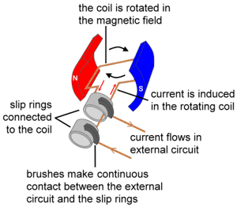
Transformers
Transformers step up and step down the size of AC voltages. Step up transformers are used to step up the voltage from a power station. Electricity is transmitted at high voltages to keep the current low (and therefore the energy losses in the form of heat low – I²R losses).
Transformers are two coils of wire wound on an iron core. To work out the voltages we can use the following equation:
V_{p} / V_{s} = N_{p} / N_{s}
Since power = voltage x current we can also use the following equation to calculate currents:
V_{p} / I_{p} = V_{s} / I_{s}
Isolating transformers are used for safety resons in some circuits e.g. bathroom shaver socket. The transformers limit the risk of contact between live parts and the earth lead. In this case the primary and secondary coils have the same number of turns on each.
Rectification
A diode only allows current to flow through it in one direction. A diode can be used to rectify an alternating voltage i.e. change it from AC to DC.
One diode forms a half wave rectifier.
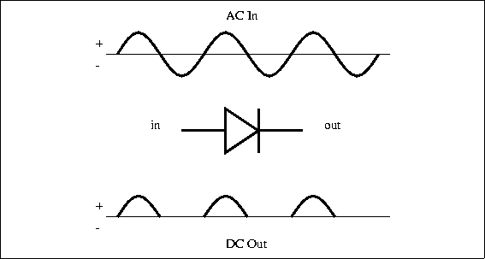
Four diodes in the form of a bridge circuit can be used to form a full wave rectifier.
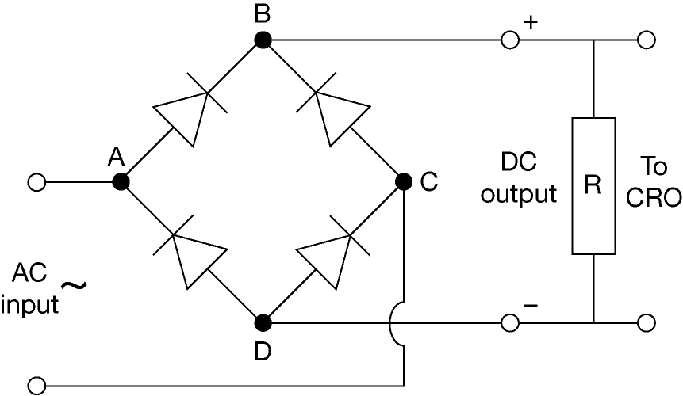
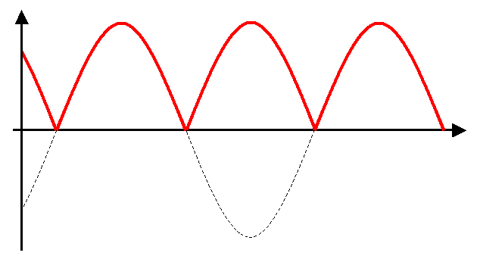

A capacitor store charge which can be discharged later. A capacitor is used to smooth the output from a full wave rectification circuit.
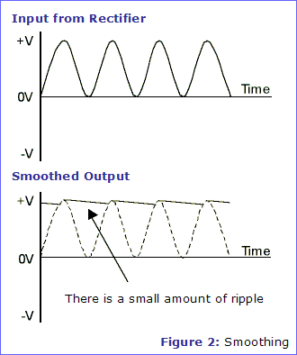
Logic circuits
Logic gates can be used to process information from potential divider circuits and thermistors, LDRs switches.
The output from logic gates could be used to light an LED. The output from a logic gate has low power. It is often used to switch on a high voltage circuit by using a relay switch.

NOT gate (inverter)
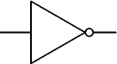 |  | Input A Output Q  0 1  1 0
Traditional symbol |  | Truth Table

AND gate
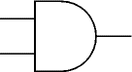 |  | Input A Input B Output Q  0 0 0  0 1 0  1 0 0  1 1 1
symbol |  | Truth Table

NAND gate (NAND = Not AND)
.
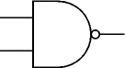 |  | Input A Input B Output Q  0 0 1  0 1 1  1 0 1  1 1 0
symbol |  | Truth Table

OR gate
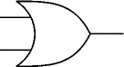 |  | Input A Input B Output Q  0 0 0  0 1 1  1 0 1  1 1 1
symbol |  | Truth Table

NOR gate (NOR = Not OR)
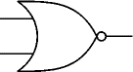 |  | Input A Input B Output Q  0 0 1  0 1 0  1 0 0  1 1 0
symbol |  | Truth Table

A bistable latch circuit can be used in a car or a burglar alarm. Once triggered it will remain on. It can be made using NOR gates.
Transistors are used to make logic gates. They are electronic switches.
A small base current (I_{b}) is needed to switch a greater current flowing through the collector (I_{c}) and emitter (I_{e}).
I_{e} = I_{b} + I_{c}

