**Motion of Satellites**

**Definition of a Satellite**

**Forces and Objects moving in a circular path**

Objects moving in a circle are always changing their direction. On the diagram below use arrows to show the direction of the Earth’s motion:

Earth

Sun

As your diagram shows, anything moving in a circular path is **always changing direction**. To do this **there must be a force** and it is directed towards the centre of the circle. This is called the **centripetal force**.

There are three things that affect the size of this **centripetal force**:

**Mass** of the object.

**Speed** of the object.

The size of the circular path (**radius**).

**Rubber Bung Experiment**

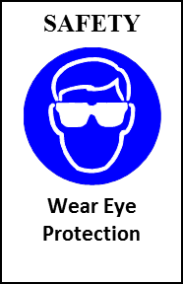

As the **mass** of the object **increases**, the **centripetal** **force** required to keep it moving in a circular path **increases/decreases**.

As the **speed** of the object **increases** the **centripetal force** required to keep it moving in a circular path **increases/decreases**.

As the **radius** of the object’s path **increases** the **centripetal force** required to keep it moving in a circular path **increases/decreases**.

Use this information to label the three satellites by interpreting the data in the table.

|  |  |
| --- | --- |
| Satellite name | Time to complete one orbit |
| Astra IIb | 24 hours |
| Amax 43II | 52 hours |
| AVHRR | 0.75 hours |

[](http://frpic.com/vectors/earth-vector/earth-vector.png)

**Recap Previous Work on Gravitational forces**

Inverse Square Law

As the distance from the sun to a planet doubles the force of gravity falls to a quarter of the value.

As the distance is trebled, the force falls to 1/9 of the value.

At an orbit of R, the force F = 64000 N,

What would be the forces at:

2R_________________

3R_________________

4R_________________

F

 F/4

Sun

R

F/9

2R

3R

**Centripetal forces applied to orbits in the solar system**

The first important point to remember is that the **planets stay in orbit** around the sun due to their **motion** as well as the **force of gravity**. It is the **gravity** that is providing the **centripetal force**.

|  |  |  |  |  |  |  |
| --- | --- | --- | --- | --- | --- | --- |
| **planet** | **mass** | **diameter** | **distance from sun** | **year** | **day** | **no of moons** |
|  | (Earth =1) | km | (million km) | Earth days | hours |  |
| mercury | 0.05 | 4880 | 58 | 88 | 1416 | 0 |
| venus | 0.81 | 12112 | 107.5 | 224 | 5832 | 0 |
| earth | 1 | 12742 | 149.6 | 365 | 23.93 | 1 |
| mars | 0.11 | 6790 | 228 | 687 | 24.62 | 2 |
| jupiter | 318 | 142600 | 778 | 4343.5 | 9.83 | 16 |
| saturn | 95 | 120200 | 1427 | 10767.5 | 10.23 | 17 |
| uranus | 14.5 | 49000 | 2870 | 30660 | 10.82 | 15 |
| neptune | 17.5 | 50000 | 4497 | 60225 | 15.8 | 8 |
| pluto | 0.003 | 2284 | 5900 | 90520 | 153.6 | 1 |

Planetary data

As we move further away from the sun what is the general trends?

How does our knowledge of centripetal force explain these patterns?

[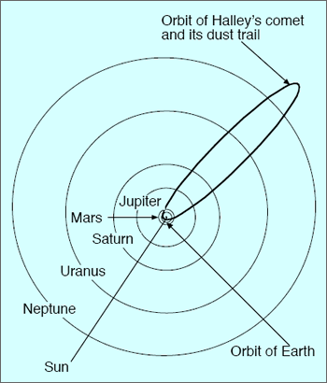](http://geology.com/articles/meteor-shower/comet-orbit-diagram.gif)

**Motion of Comets**

The orbits of comets are highly elliptical:

Label the orbit in the diagram on the right to describe

the magnitude of the comet’s speed.

**Past Paper Question:**

Question 1

1. Explain what happens to the gravitational force when the distance between a satellite

and the Earth doubles.

…...........................................................................................................................................

…...........................................................................................................................................

**[1]**

**(ii)** Explain why the speed of a comet changes as it approaches the Sun.

…...........................................................................................................................................

…...........................................................................................................................................

…...........................................................................................................................................

…...........................................................................................................................................

**[2]**

**Total (3)**

Plan and draft your answer here:

**Homework: Self Study: Uses of Satellites Due Date:**

* Using your revision guide produce a summary page of the different types of artificial satellite.
* You must compare their orbital speeds and altitudes.
* You need to include separate sections describing how communications satellites use microwaves and how these microwaves are affected by the atmosphere

**Scalar and Vectors**

Sort these quantities into two groups. One where direction is important and one where it’s not.

**Mass Force Energy Power Acceleration Velocity**

|  |  |
| --- | --- |
| Direction is important | Direction is not important |
|  |  |

One important example of a quantity where **direction is important** is Force. How could you combine **3 N** and **4 N** forces to give a resultant force of **7 N**?

How could they be combined to give **1 N**?

What about **5 N**?

One example of a quantity that does **not require direction** is **mass**. There is only one possible outcome when combining 3 kg and 4 kg, which is 7 Kg.

These two groups of quantities have specific names which help us decide how to tackle them.

**Vectors**

Definition

Example:

**Scalars**

Definition

In P5 we will be looking at motion by considering vectors. So here are the first couple of things to conform.

**Speed** and **velocity** are not the same. **Velocity** is a **vector** and requires a **direction** and **speed** is a **scalar**. Also **distance** is a **scalar** and **displacement** is a **vector**.

**Vector addition**

Vector addition requires some knowledge of the relative directions of vectors. This is usually dealt with by a **diagram**. There are then two ways of **combining vectors**: **Scale Diagram** or **Trigonometry**.

**Scale diagram method.**

##### Example: Aircraft and a cross wind

An aircraft flying on an initial bearing of 0o at 350 m/s with a wind blowing west-east at 50 m/s

50 m/s

Draw this vector diagram to scale on graph paper.

The resultant should be 354 m/s and the angle should be about 8º.

350 m/s

R (resultant)

C:\Users\rontrousers\AppData\Local\Microsoft\Windows\Temporary Internet Files\Content.IE5\4BDKRPQP\MC900383852[1].wmf

**Trigonometry method**

If your maths is up to it you could use trigonometry and Pythagoras’ theorem.

**Equations of Motion**

Recap of work done in P3

|  |  |  |
| --- | --- | --- |
|  | Velocity | Acceleration |
| Typical units |  |  |
| Equation |  |  |

|  |  |  |
| --- | --- | --- |
|  | Distance /Time graph | Speed /Time Graph |
| No movement |  |  |
| Constant movement |  |  |
| Acceleration |  |  |

**Equations of motion**

In your examination your exam you will be asked to solve problems involving acceleration. You need to know the following four equations (you don’t need to remember them)

**v2 = u2 + 2as**

s = displacement (or distance)

### v = u + at

### s = (u + v) t

2

u = initial velocity (or speed)

v = final velocity (or speed)

a = acceleration

v2 = u2 +2as

s = ut + ½ at2

t = time

If you look carefully at the equations you will notice they all contain 4 quantities (three are needed for the fourth to be found). The key to using these is to list SUVAT and fill in what you know. Identify what you need to find out and choose the correct equation.

********************you will need to rearrange the equations so practise makes perfect*************

Let’s go through a question step by step. You’ll need some colours!

Example 1

A horse accelerates steadily from rest at 4 m/s2 for 3s.

What is its final?

x

✓

✓

✓

✓

**Step 1**

s =

u = 0 (rest = zero m/s)

v = ?

a = 4 m/s2

t = 3 s

✓

### s = (u + v) t

2

### v = u + at

**v2 = u2 + 2as**

**v2 = u2 + 2as**

**v2 = u2 + 2as**

x

*x*

✓

✓

✓

✓

✓

✓

v2 = u2 +2as

s = ut + ½ at2

**Step 3** circle what you want to find

**Step 2** tick everything that’s known

**v2 = u2 + 2as**

**Step 4** find the equation that only has ticks and crosses: v = u + at

V = 0 + (4 x 3) = **12 m/s**

Have a go at this one yourself (use the mini whiteboard to start with)

1.

A particle is accelerated uniformly from rest, so that after 10 seconds it has achieved a speed of 15 m/s. Find its acceleration.

v = u + at v2 = u2 + 2as

s = ut + ½ at2 s = (u+v)t

2

s =

u =

v =

a =

t =

2.

A particle is accelerated uniformly from rest, so that after 10 seconds it has achieved a speed of 15 m/s. Find the distance it has covered?

**What is a projectile?**

There is one important **assumption** we need to make when dealing with **projectiles** at GCSE. That is that we **ignore wind resistance** or only consider situations where wind resistance is **negligible**.

In which of the following cases is it not appropriate to ignore wind resistance:

**Falling Cat Golf Ball Feather Marble**

**The Physics of Projectiles**

The **path** taken by a projectile (**trajectory**) always follows a pattern. All projectile **trajectories** are a **parabola**. We can describe the shape as **parabolic**. Make sure you don’t confuse the two.

Launch Angle

The **distance the travelled** by the projectile (**range**) depends on the **launch speed** and **launch angle**. The **maximum** range is achieved with a launch angle of **45°.**

Try the following simulation: <http://phet.colorado.edu/en/simulation/projectile-motion> to prove that a launch angle of 45**°** gives the maximum range (**without air resistance**).

**Observing Projectile Motion**

A projectile can also be launched horizontally from somewhere above the ground!

The best way of observing the motion of a projectile is by using **multi-flash photography**. This is done by flashing a light on a projectile in the dark and using a camera to record the position of the projectile at each flash of a stroboscope:

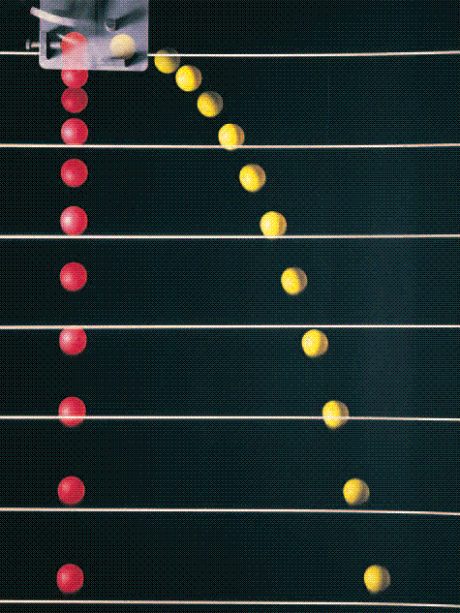

A stroboscope is simply a bright lamp that flashes regularly.

If we know how many times a second the lamp flashes we can work out the time between pictures.

The scale behind allows us to make measurements of displacement.

This is a representation of a multi-flash photograph of a projectile:

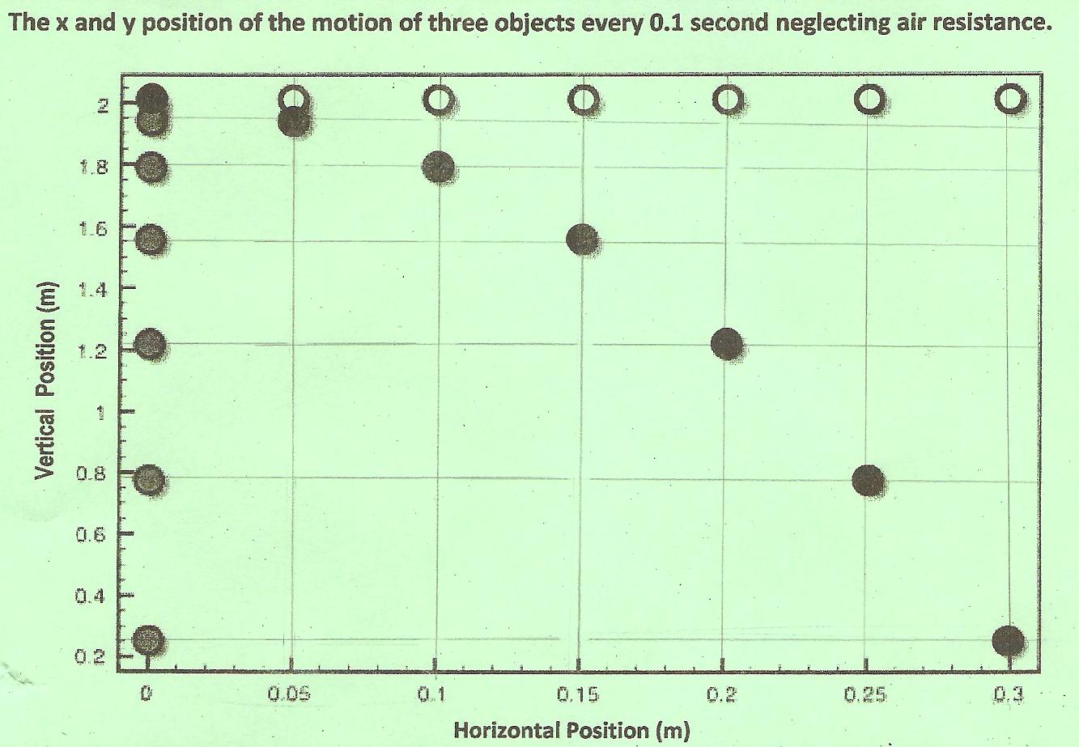

The distances on this photograph have been measured for you. The time between the flashes was 0.1 s.

**Predicting the motion of a projectile**

Remember section P5b…..**displacement** and **velocity** are both **vectors**. This is useful when dealing with projectiles. The key is to consider the **horizontal** **motion** and **vertical motion** of a projectile **separately**.

**Considering horizontal motion**:

If there is no wind resistance, then there is **no horizontal force** acting on a projectile. This means there is **no acceleration** or **deceleration** and the projectile will move horizontally at **constant speed**.

Use the diagram above to complete the following table for the horizontal displacement and time:

|  |  |  |  |  |  |  |  |
| --- | --- | --- | --- | --- | --- | --- | --- |
| **Time (s)** | **0** | **0.1** | **0.2** | **0.3** | **0.4** | **0.5** | **0.6** |
| **Horizontal displacement**  **(m)** |  |  |  |  |  |  |  |

**Calculate** the velocity between 0 and 0.1 s:

Velocity = displacement / time = 0.05 / 0.1 = 0.5 m/s

Now use your calculator to find the speeds between 0.1 and 0.2, 0.2 and 0.3, 0.3 and 0.4, 0.4 and 0.5 and finally 0.5 and 0.6.

You should see that the horizontal velocity is constant at 0.5 m/s.

**Considering Vertical Motion:**

The **only force** acting vertically is the projectile’s **weight**. This causes the object to **accelerate** vertically downwards at **9.81 m/s2**. **Remember:** all objects accelerate vertically downwards at **9.81 m/s2**no matter what the mass.

Complete the table for the vertical displacement (You’ll have to do some subtraction) and plot your data:

|  |  |  |  |  |  |  |  |
| --- | --- | --- | --- | --- | --- | --- | --- |
| Time (s) | 0 | 0.1 | 0.2 | 0.3 | 0.4 | 0.5 | 0.6 |
| Vertical displacement (m) | 0 | 0.05 | 0.2 |  |  |  |  |

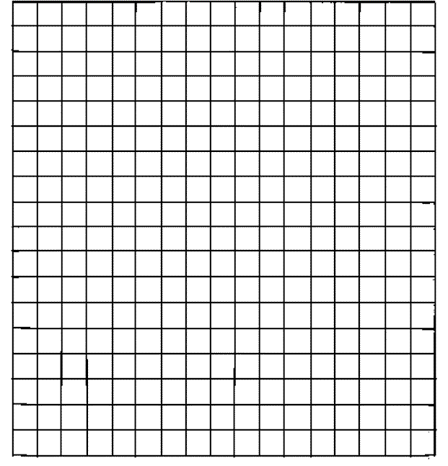

0 0.1 0.2 0.3 0.4 0.5 0.6 0.7

Time (s)

As you can see from your graph, the **vertical acceleration is constant**.

When tackling projectile questions, you must consider **vertical** and **horizontal** motion **separately**.

**Horizontal** velocity remains **constant**.

**Vertical** acceleration is **9.81 m/s2**

Vertical motion can be analysed using **SUVAT**

**Example**

A ball is thrown horizontally from a cliff with an initial velocity of 3m/s. It landed 9 meters away.

a. How long did it take to land?

b. How high is the cliff?

c. What was its velocity just before hitting the ground?

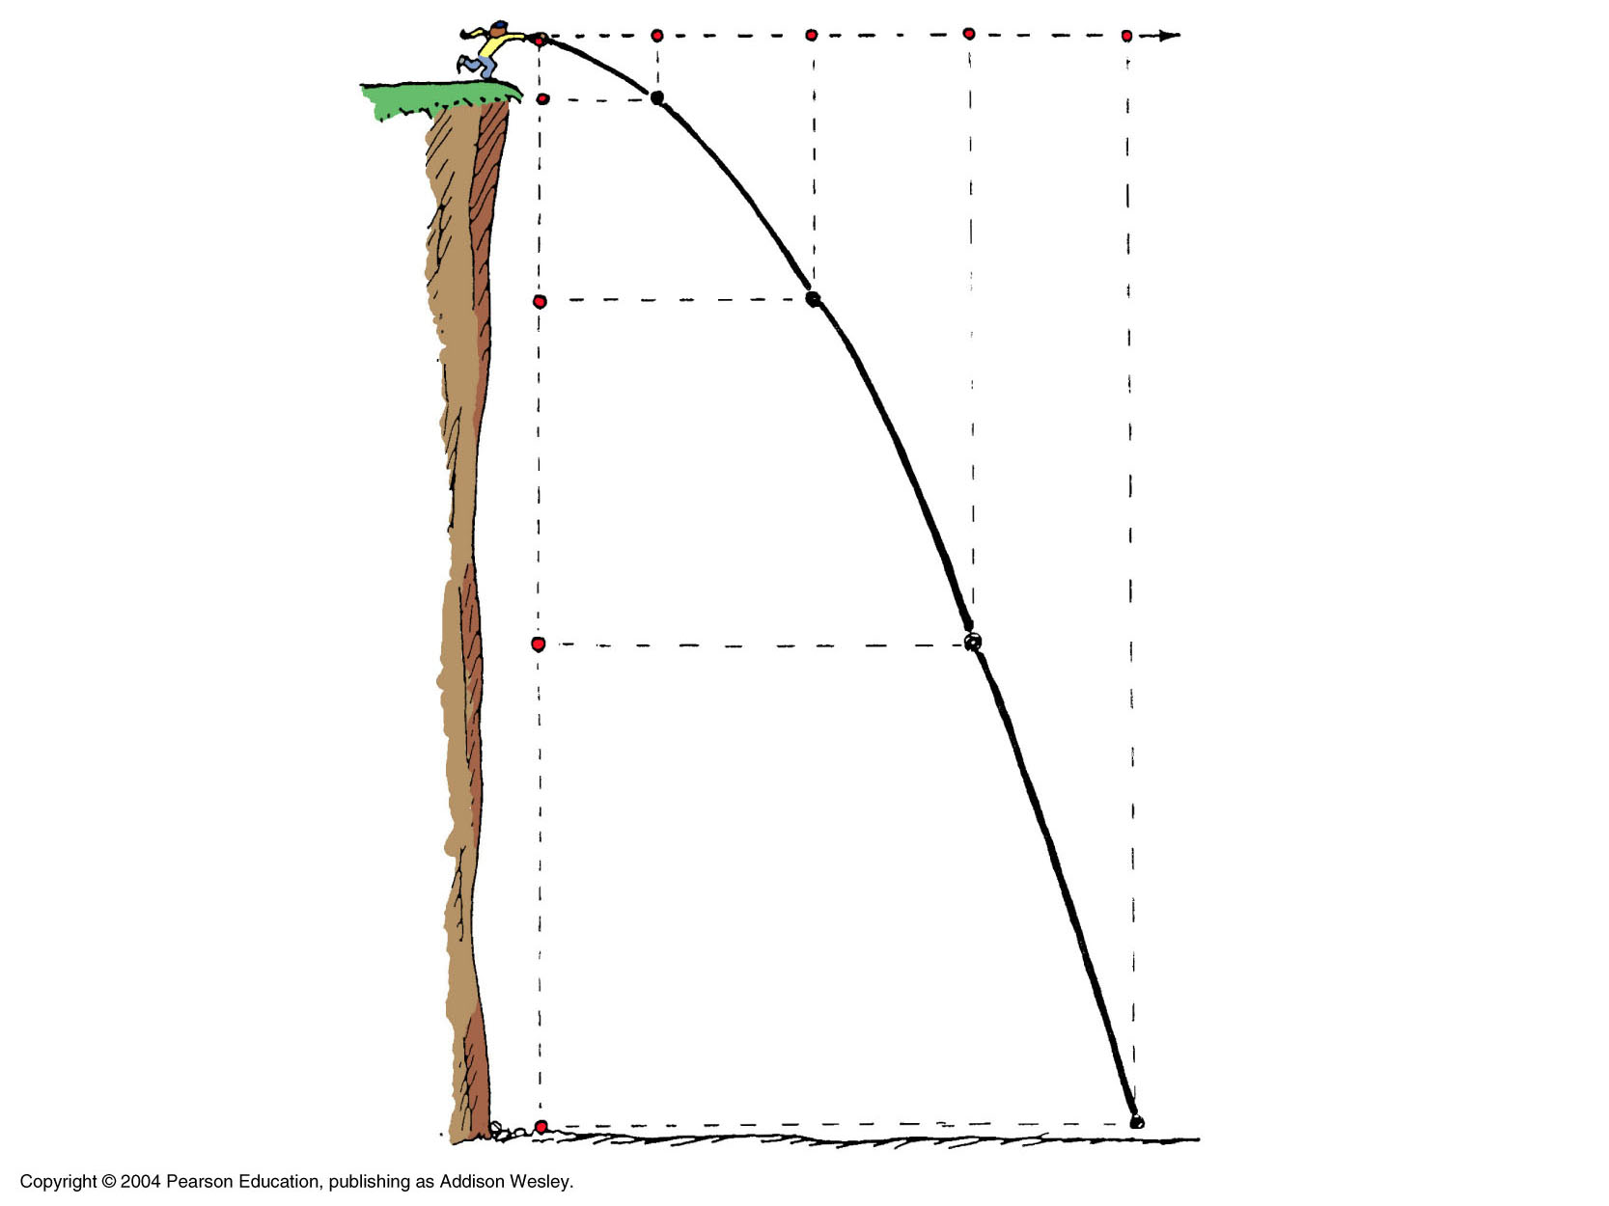

**Newton’s Third Law of Motion**

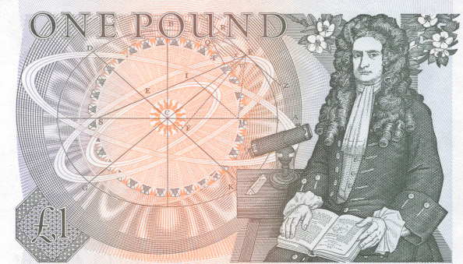Here’s the great man himself on the back of a pound note. You’ll be able to see how ancient your Physics teacher is…see if they remember Isaac and his Toblerone on the back of the pound note!

One of the important things Isaac Newton did was to come up with three Laws of motion. In this section we are going to look at is third law of motion in detail.

Newton’s third law applies when **objects interact** (**collide**), we’ll concentrate on just two objects interacting.

Consider the following diagram of two ice skaters interacting. If the one on the left pushes the one on the right, what will happen?

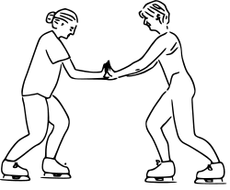**Both** skaters will move apart:



If both skaters have moved apart, they have both gained velocity. If they gain velocity they have both accelerated and both must have experienced a force!

Newton explained this in his third law. It’s a bit of a tongue twister, but should make sense:

*If body A exerts a force on body B, body B will exert an equal and opposite force on body A.*

Some examples of third law pairs:

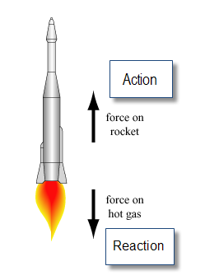 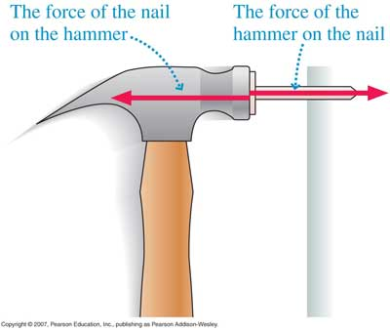

**Forces in collisions and explosions**

Newton’s third law of motion can be used to explain what’s happening during any collision or explosion. We combine our previous knowledge of **momentum** with our new knowledge of action and reaction.

In any collision between bodies or explosion the **total momentum** of the bodies **remains constant**. To make full sense of this, you need to remind yourself that **momentum** is a **vector** and therefore has **direction**.

The total momentum before a collision is equal to the total momentum after a collision.

Here’s an example:

A van of mass 3000 kg travelling at 15 m/s collides with a stationary car of mass 1000 kg at traffic lights. They both move forward together. What is their speed after the collision?

**Step 1:** Draw a before and after diagram and label all the masses and velocities.

**Before After**

15 m/s 0 m/s v

  

3000 kg 1000 kg 4000 kg

Notice we’ve labelled the unknown velocity v because we usually use v for final velocity and also notice that we treat the two vehicles as one because they are joined.

**Step 2:**  so that the examiner knows what you are doing write down:

**Total Momentum before = total momentum after**

**(M1 U1) + (M2 U2**) **= (M1+M2)V**

**Step 3:** Put in the values (3000 x 15) + (1000 x 0) = (3000 + 1000) v

**Step 4:** solve 45000 + 0 = 4000 v

45 000 = 4000 v

45 000/4000 = v

11.25 = v

**V = 11.3 m/s**

Here’s an example of an **explosion** (when the total **momentum to start is zero**)

A cannon of mass 1000 kg fires a cannon ball of mass 10 kg at a speed of 100 m/s. How fast will the cannon recoil?

**Before After**

0 m/s 0 m/s v 100 m/s

C:\Users\rontrousers\AppData\Local\Microsoft\Windows\Temporary Internet Files\Content.IE5\4BDKRPQP\MC900351494[1].wmf C:\Users\rontrousers\AppData\Local\Microsoft\Windows\Temporary Internet Files\Content.IE5\4BDKRPQP\MC900351494[1].wmf

1000 kg 10 kg 1000 kg 10 kg

total Momentum before = total momentum after

(1000 + 10) x 0 = (1000 x v) + (10 x 100)

0 = 1000v +1000

1000 v = -1000

v = -1000/1000

**v = -1m/s**

What does the – sign mean?

**Gases and momentum**

Lets start with our model of a gas:

1. Tiny particles with kinetic energy.
2. They are far apart and are free to move.
3. The higher the temperature the faster they move.

Our knowledge of Newton’s Laws point out that when a **particle** of **gas** **collides** with the **walls** of its container it creates a **force**. This is what causes gas **pressure**.

*How does changing the volume of the container affect the pressure?*

If the temperature stays the same (and the number of particles) what will happen to the speed (and kinetic energy) of the particles?

……………………………………………………………………………………………………………….

Compare how often the particles collide with the walls of our smaller container compared with the one at the beginning?

……………………………………………………………………………………………………………….

What can you say about the pressure in this smaller container?

……………………………………………………………………………………………………………….

*How does changing the temperature affect the pressure?*

If the volume stays the same and we don’t change the number of particles what will happen to the frequency of collisions with the container walls?

……………………………………………………………………………………………………………….

**Gas pressure and momentum (the maths bit)**

Whilst in our previous examples of momentum we said that the total momentum before was equal to the total momentum after. However the momentum of the individual bodies did change. This was because forces were applied to each body:

**Force = rate of change of momentum**

**Force = change in momentum**

**time**

**F = mv-mu**

**t**

We’ll use this to explain gas pressure mathematically.

Consider a particle with mass m, inside a sealed box travelling with a velocity v. Its travelling perpendicularly to the container wall. When it hits the container wall it rebounds at exactly the same speed but in the opposite direction:

particle

Container wall

v v

m m

Before collision After collision

The speed might not have changed but the velocity has! this is because the direction has changed. Mathematically the change in velocity is 2v and the change in momentum is 2 mv.

The force exerted by the particle f = 2mv/t where t is the time between collisions between the particle and the wall of the container.

This force exerted by gas particles is the principle behind rocket engines. Whilst the masses of the particles and the rocket are very different, the momentum change in both cases is the same.

|  |  |  |
| --- | --- | --- |
|  | Rocket | Gas particle |
| Mass | high | low |
| Speed | low | high |

This section is mostly “**book work**” so you’ll be able to get through this yourself. You must learn the facts.

**Communicating with Satellites**

In the case of a **geostationary** satellite (orbits at **36 000 km** above the equator), **microwave** signals are **transmitted** to the **satellite**. When the signal has been received it is **amplified** and **re-transmitted** back to the earth’s surface where it is picked up by a **receiver**. The transmitters and receivers are **parabolic** in shape.

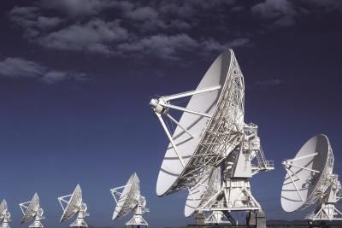

The signals are **digital** and have two major **benefits**. The **signal** is **less prone** to the effects of **noise** and they **do not attenuate** as **quickly** as an analogue signal. This is because the microwaves have a **short wavelength** and are therefore **not** **diffracted** very much. This is because the parabolic transmitters are much bigger than the wave lengths used.

One problem with geostationary satellites is that they all share the same very **crowded orbits**.

Satellite signals are affected by the **ionosphere**. If they are below a frequency of **30 MHz** the waves are **reflected**. Above **30 GHz**, the waves are **absorbed** and **scattered**. This would cause a reduction in the **strength** of the signal. The ionosphere is between 100 km and 500 km above the earth. Radio waves are reflected because they are **refracted** in the **different layers** and are eventually **totally internally reflected**.

So guess what….? the frequencies used for satellite communication are those that lie between **30 Mhz and 30 GHz**

You now need to look back at your year 10 **P1** work to remind yourself about diffraction and the ionosphere.

**Diffraction Ionosphere**

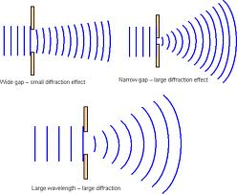 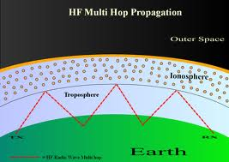

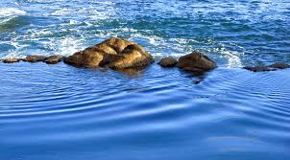The photograph shows waves passing through gaps between rocks. As they travel past each other they combine to give the pattern shown. This combination of waves is known as **interference**.

**Interference**

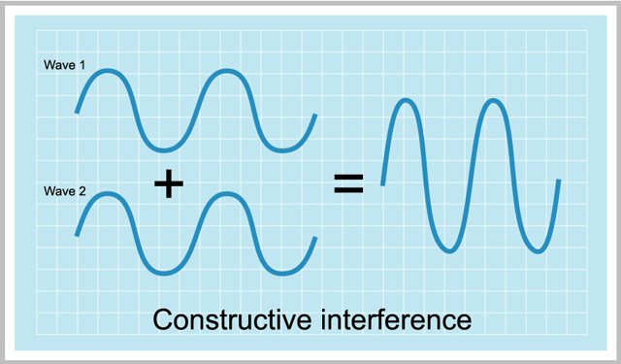

When two waves overlap with the **crests** and **troughs** in the same place, they are known as being **in phase**. The result is a larger wave and the process is called **constructive interference**.

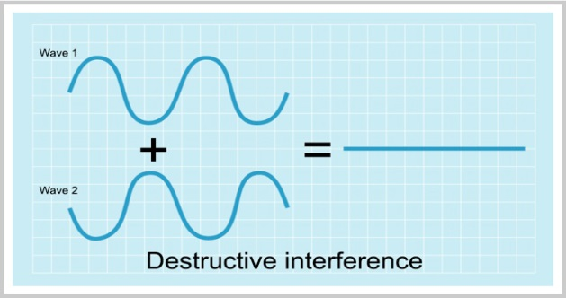

When two waves overlap with crest aligned with troughs, they are known as being **out of phase**. The result is a smaller wave and the process is called **destructive interference.**

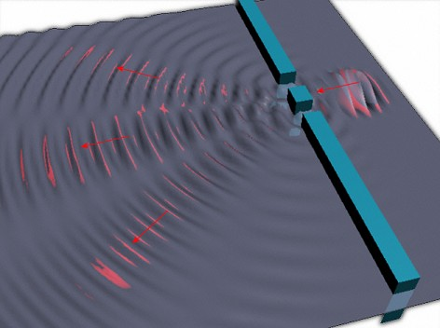

This diagram is an interference pattern of water waves. An explanation of how it is formed is beyond what can be explained here. You will need to cover this in class.

**Interference patterns** of **light** are evidence of light acting as a **wave**. The sources of light have to be very close together for this to happen.

**Polarisation of waves**

Transverse waves can oscillate in many directions at right angles to the direction of wave motion. When light (or any transverse wave) only oscillates in one direction it has been **polarised**. Polarisation can be achieved by a filter such as **polaroid sunglasses**.

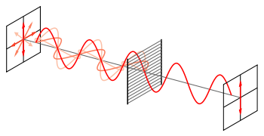

How to represent polarised and unpolarised waves:

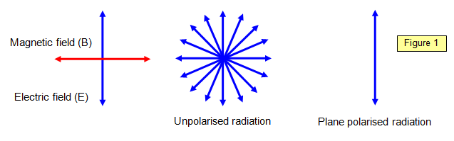

**Historical stuff**

**Isaac Newton** thought light was a particle and therefore would travel faster in a denser medium.

**Huygens** thought light was a wave and would therefore travel slower in a denser medium.

Who was right?

With the exception of a couple of equations (easy marks!) this section is a repeat of work covered in P1 in year 10.

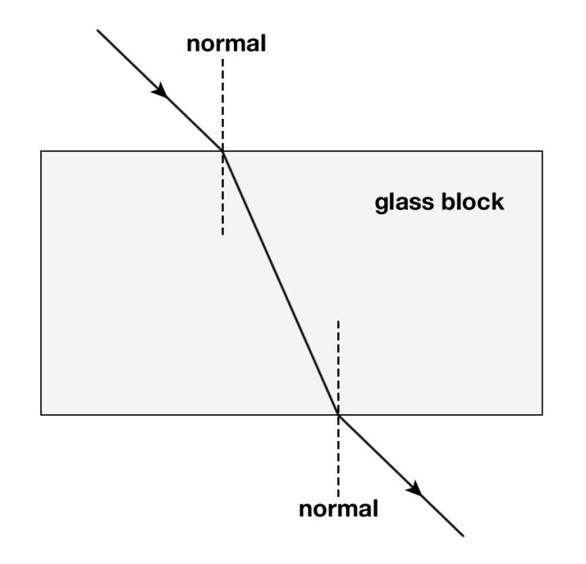Light **changes speed** when it travels from one medium into another. In this case, the light starts in air and **enters the glass** (more dense). It travels **slower** in the glass and deviates towards the normal.

As the light **leaves the glass** and enters the air (less dense) it **speeds up** and deviates away from the normal.

The amount of **deviation** is indicated by something called the **refractive index.** The **higher** the refractive index the **greater** the **deviation**.

**Refractive index (n) = speed of light in vacuum**

**speed of light in medium**

The **different colours** of light in white light travel at **different speeds** in glass and perspex. They therefore refract by a different amount and are **dispersed**

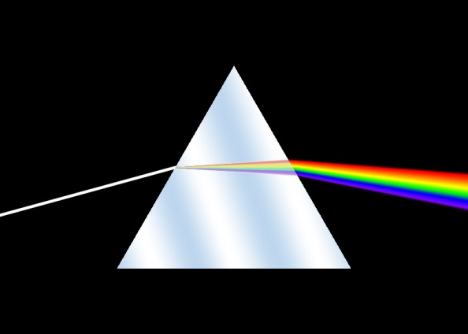

**Trivia**: Name the album and the band.

**Snell’s Law**

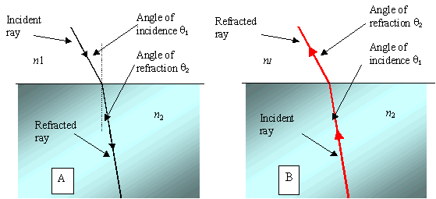

The angles can be predicted using this equation known as **Snell’s law**:

**Refractive index (n) = sin (angle of incidence)**

**sin (angle of refraction)**

Refractive index affects the **critical angle** (P1 year 10 again). **The higher the refractive index the greater the critical angle**

Key terms to get to grips with: **Focal Point, focus, focal plane, principle axis, converge, diverge.**

We will be dealing with just two types of lens: **converging** and **diverging**, and how they focus light to form images.

**Converging lens**

Sometimes called a **convex** lens because of its shape, a **converging** lens makes light rays converge:

F

Principal axis

Optical centre

The light rays are **parallel** and come from a **distant object** somewhere to the left of the lens. The rays pass through the lens and are focused at **F** the **focal point**.

The next diagram shows rays from another distant object somewhere to the bottom left of the lens:

Focal plane

The rays are focused on the **focal plane**. This is a vertical line passing through the focal point. Rays coming from different objects in different places can be shown by **ray diagrams**.

**Ray diagrams**

The position of an image formed by light rays passing through a converging lens can be found by simply drawing the path taken by two rays.

object

F

F image

The **image** is **upside down** so is an **inverted** image. It’s also **smaller** than the object so we call it **diminished**.

Lets do it step by step and then have a go at one or two for yourself.

**Step 1** Draw in the lens, **principal axes**, **focal points** and **object**.

object

F F

**Step 2** Draw a ray from the **top of the object** through the **optical centre** (centre of the lens) and continue it some way beyond the focal point.

object

F F

**Step 3** Draw a ray **parallel to the principal axis** until it touches the **centre line** of the lens

object

F F

**Step 4** Continue this line from the centre of the lens through the **focal point**.

object

F F

**Step 5** Draw in the **image** where the **two rays cross**.

object

F F

image

This link shows how the size of the image varies depending on the position of the object: <http://www.acs.psu.edu/drussell/Demos/RayTrace/Lenses.html>

Have a go at these ray diagrams:

**F**

**F**

**2F**

**2F**

Describe the image:

**F**

**F**

**2F**

**2F**

Describe the image:

**F**

**F**

**2F**

**2F**

Describe the image

This one is quite tricky because you don’t get a real image. It’s how a magnifying glass works

**F**

**F**

**2F**

**2F**

Describe the image:

**Magnification**

The magnification of any lens system is given by:

**Magnification = image size**

**object size**

**Uses of lenses *the camera and projector***

Your job is to find some ray diagrams to show how a camera and projector work. Make sure you understand the effect of changing the position of the lens on bth the focus and size of image.