P5 – Space for reflection
Module Summary
Satellites, gravity and circular motion
A satellite is an object which orbits a larger object. The moon is a natural satellite of the Earth. Man-made satellites can be used for:
- Communications (geo)
- Weather forecasting (both)
- Military use / spying (polar)
- Scientific research
- GPS
A geostationary satellite stays in a fixed position relative to the Earth. It sits above the equator and has an orbit time of 24 hours. Lower polar orbit satellites can orbit in a few hours.
Gravity is an attractive force between masses. Gravity provides the centripetal force required for circular motion. Satellites move in a circle because of gravity and their movement. The closer the masses are the stronger the force. Lower orbit satellites orbit more quickly because of the stronger force of attraction.

Vectors and equations of motion
A scalar quantity just has a magnitude. A vector quantity has magnitude and direction. Speed is a scalar quantity, velocity is a vector quantity. When adding vectors both their size and direction need to be taken into account. Vector diagrams can be used to add vectors.
Acceleration due to gravity on Earth = 10m/s⁻² .
For objects with constant acceleration, the equations of motion apply:
v = u + at
s = $\frac{u +v}{2}$ t u = initial velocity v = final velocity
v² = u² + 2as s = displacement a = acceleration
s = ut +½ at² t = time

Projectile motion
The trajectory for a projectile is parabolic. The only downwards force acting on it is gravity. Moving sideways has no effect on the downwards force. Treat the vertical and horizontal motions as separate.
Use equations of motion for vertical movement and speed = distance ÷ time for horizontal movement
.
Momentum
If an object is difficult to stop it has a lot of momentum
Momentum = mass x velocity
When an object collides with another object the two objects exert an equal and opposite force on each other.
Force = $\frac{change in momentum}{time}$
The longer an object takes to stop in a collision the smaller the force acting on it. Cars have seatbelts, crumple zones and airbags. All are designed to bring the passenger to a stop in as long a time as possible.
When there is interaction between two objects (explosion, collision) momentum is conserved. Total Momentum before the interaction = total momentum after.

Satellite communication
Microwaves and radio waves are used to transmit information.
Microwaves and higher frequency radio waves can be transmitted to orbiting satellites and then retransmitted back to Earth. Radiowaves with a frequency less than 30MHz are reflected by the ionosphere. An aerial is needed for radio waves, a ‘dish’ is needed for satellite TV signals.
When waves pass through a gap or around an edge they get diffracted (spread out)
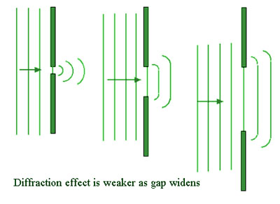
There is less diffraction as the gap gets wider and as the wavelength gets shorter. The maximum diffraction happens when the size of the gap equals the wavelength. As longer wavelengths diffract more, long wave radio is very good for broadcasting as the waves can diffract around hills and over the horizon.
Long wave radio waves carry signals by amplitude modulation (AM).

Nature of Waves
When waves meet they add up (interference). This gives areas of destructive interference (cancelling) and constructive interference (larger amplitudes. With sound waves this will give quiet and loud areas.
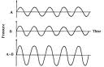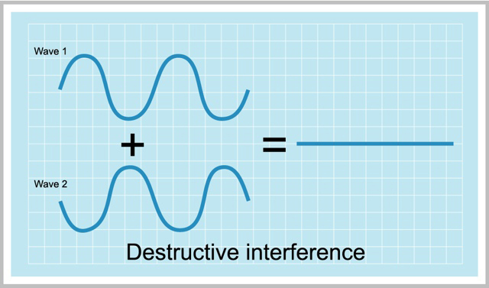

Constructive interference Destructive interference

- Constructive interference Path difference = an even amount of half wavelengths
- Destructive interference Path difference = an odd amount of half wavelengths
Electromagnetic waves are transverse. This means that they can be polarised. Polarisation means that the wave vibration is in one direction only.

Unpolarised light Polaroid Plane polarised light
Polarisation is used in sunglasses. By polarising the light they have reduced the intensity of light transferring through the glasses.

Refraction of Waves
Refraction is the bending of waves due to a change in speed. Refraction happens at bounderies between different medium.
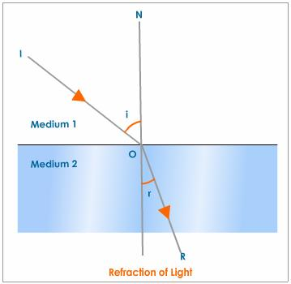
There is greater refraction when there is a greater change in wave speed and refractive index. The refractive index of a medium is given by Snell’s Law n = $\frac{\sin{i}}{\sin{r}}$ (i = angle of incidence, r = angle of refraction)

When white light passes through a prism – dispersion happens. The light gets split up into the 7 colours of the spectrum. This happens because each colour has a different wavelength. Blue light is refracted more than red light (ROYGBIV).
When waves hit a dense to less dense boundary total internal reflection can happen if the angle of incidence is at the critical angle or higher. The critical angle can be calculated using: sin c = n_{r} / n_{i}
The higher the refractive index of a medium the lower its critical angle.
Optics
A convex lens is also known as a converging lens as it brings rays of light to a focus. Convex lenses can be used as magnifying lenses, in cameras and in projectors. Projectors and cameras produce real images (ones that can be captured onto a screen).
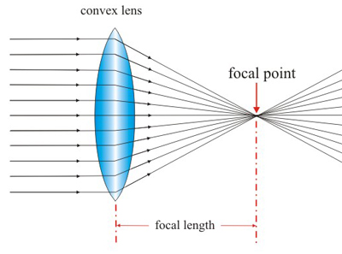

The position and size of real images can be found from ray diagrams.
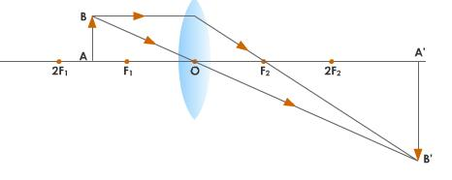
- Draw in the convex lens and the focus points.
- Draw in a scale object. The arrow shows the way up it is.
- Draw a line from the top passing through the centre of the lens.
- Draw a second line from the top parallel to the principal axes to the lens. Then a line from there through the focus.
- Where these two lines meet is the image.

Magnification = $\frac{image size}{object size}$

