What is an analogue signal? Draw a diagram.

What is a digital signal? Draw a diagram.
How are microwaves used for communication?

What happens to microwaves as they pass through the atmosphere?
Define and draw diagrams to show:
Total Internal Reflection –

Critical Angle –

Infrared Cooking | Microwave Cooking  Name 4 advantages of digital signals:  Explain the term ‘multiplexing’:
 | Compare FM radio to DAB (digital) radio:
 | P waves | S waves
Type of Wave
Relative Speed
Can travel through
When does an earthquake happen?
How do we detect earthquakes?
Explain what this diagram shows about differences between radio and microwave transmission:
What is diffraction?

Complete the diagram to show diffraction:

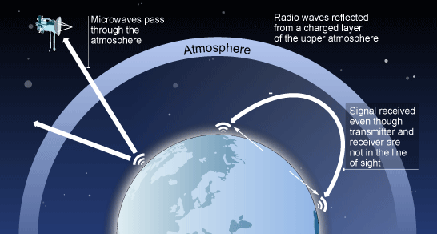

How can you work out how long you can stay in the sun for?
Name 4 things too much sun (UV rays) can cause:
What has created a hole in the Ozone Layer?
Why is this hole dangerous?

