Magnetic Fields:
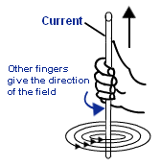
A magnetic field can be created if an electric current moves through a coil of wire.
The direction of a field around a wire can be found using the right hand grip rule. You should imagine you’re wrapping your RIGHT hand around a wire. Your thumb should point towards the direction of the current. Your other fingers will then give the direction of the magnetic field (see left).
The field pattern of a long coil of wire is similar to that of a regular bar magnet; opposite forces attract, and like-forces repel.
When a wire is placed between the poles of a magnet, the wire moves out of the gap when the current is switched on.
The X shows us that the current is flowing into the paper; it looks like the back of an arrow that we’ve just fired.
The dot (.) shows us that the current is flowing away from the paper; it looks like an arrow is coming towards us.
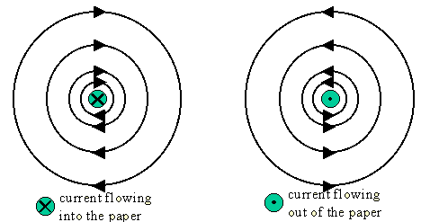
Motor Direction:
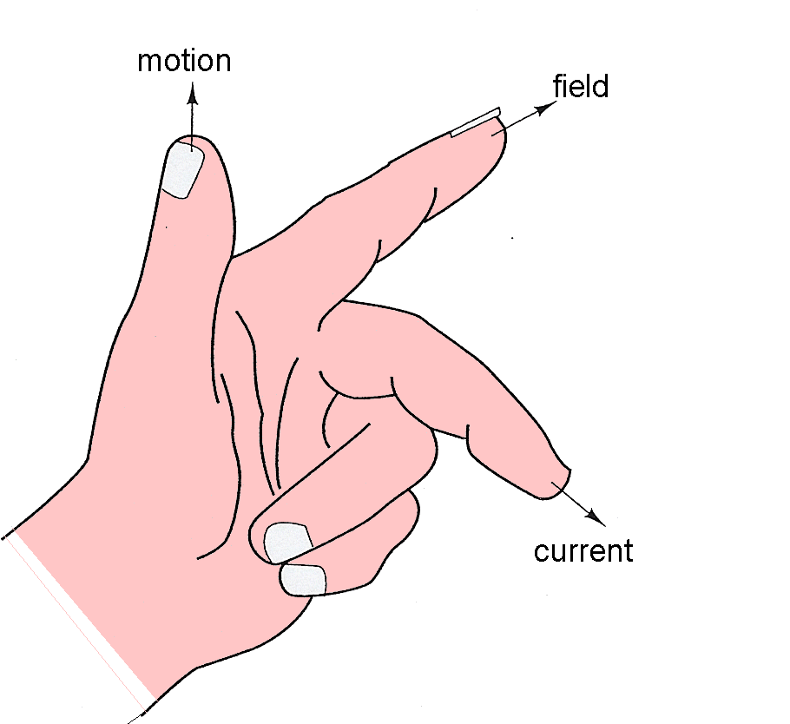
Fleming’s left hand rule can be used to predict the direction in which a motor turns.
Your Thumb = Motion
Your First Finger = Field
Your Second Finger = Current
The direction of current, magnetic field and motion are all at right angles to each other.
Turning Coils:
When a current passes through a coil, placed between the poles of a magnet, there is a force on each side of the coil. If you use Fleming’s Left Hand Rule, you can see that the motion (or forces) on each side of the coil are opposite in direction. As one side is forced up, the other is forced down – this means that the coil starts to spin.
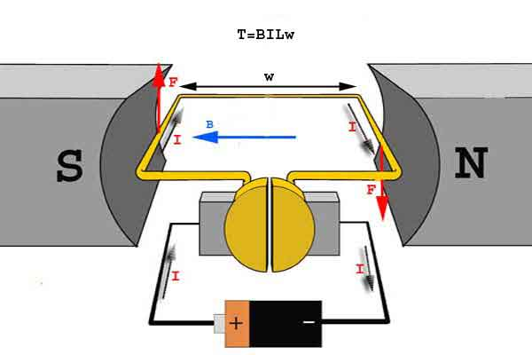
As you can see, because the direction of current changes on each side, the force or motion also changes, making the coil spin.
You can make the coil spin faster by:
- Increasing the number of turns on the coil
- Increasing the size of the current
- Increasing the strength if the magnetic field
Practical Motors:
The job of a commutator is to make the coil continue to spin.
The direction of current in the coil is revered every half turn; this ensures that the force on the coil is ALWAYS in the same direction.
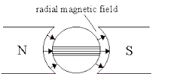
The magnets in practical motors have curved poles to give a radial magnetic field.
A radial field increases the force on the coil and keeps it constant as the motor turns. It also ensures that the field lines are always 90º to the coil.
Additional NOTES:
If the direction of the current is reversed, then the wire moves in the opposite direction – this is the same for reversing the direction of the magnetic field.

Past Papers:
PPQ(1):

PPQ(2):
PPQ(3):
PPQ(4):
Continued on next page...

PPQ(5):
PPQ(6):

PPQ(7):

Mark Schemes:
PPQ(1):
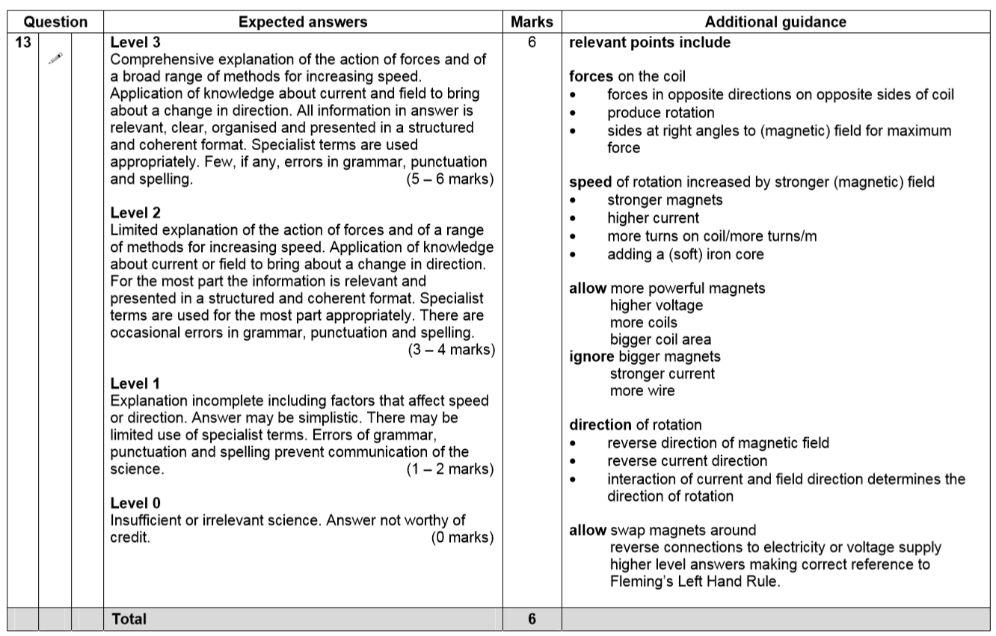
PPQ(2):
PPQ(3):
PPQ(4):
PPQ(5):
PPQ(6):
PPQ(7):

