Transistors:
In a transistor, a small base current can switch on a GREATER current through the collector.
To work out the current coming out of the emitter:
I_{e} = I_{b} + I_{c}
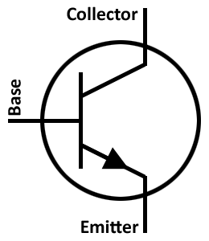
Logic Gates:
Type of Gate | Symbol | Explanation
AND | 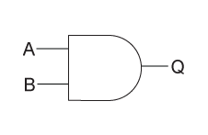 | To give a high output, both A and B must have a high output or be on. AND gates are like two switches in series; the circuit can’t work if one switch is off.
OR | 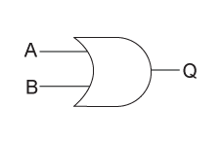 | To give a high output, one of A or B must have a high output or be on. OR gates are like two switches in parallel; only one switch needs to be on for the circuit to work.
NOT | 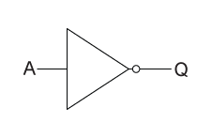 | To give a high output, the input must be low or completely off. NOT gates will give the opposite of the (single) input – the output is not what the input is.

Making an AND gate:
Two transistors can be combined to make an AND gate.
- A small input at A will switch on the upper transistor.
- A small input at B will switch on the lower transistor.
- A current at A and at B are needed to switch on the 6V supply.
The other logic gates can be made by using different combinations of transistors.
Transistor circuits ALWAYS have a high value resistor in the base circuit to limit the current.
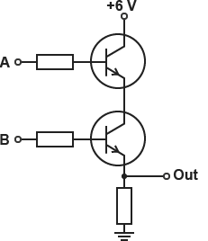
NAND and NOR gates:
Type of Gate | Symbol | Explanation
NAND |  | It behaves like an AND gate followed by a NOT gate.
NOR | 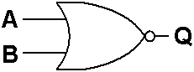 | It behaves like an OR gate followed by a NOT gate.

Truth Tables:
Truth tables show how logic gates behave.
- When there is some input (or output), a 1 is entered in the table
- When there is NO input (or output), a 0 is entered in the table
AND Gate: OR Gate:
Input A | Input B | Output
0 | 0 | 0
1 | 0 | 0
0 | 1 | 0
1 | 1 | 1
Input A | Input B | Output
0 | 0 | 0
1 | 0 | 1
0 | 1 | 1
1 | 1 | 1

NAND Gate: NOR Gate:
Input A | Input B | Output
0 | 0 | 1
1 | 0 | 1
0 | 1 | 1
1 | 1 | 0
Input A | Input B | Output
0 | 0 | 1
1 | 0 | 0
0 | 1 | 0
1 | 1 | 0

NOT Gate:
Input A | Output
0 | 1
1 | 0

Past Papers:
PPQ(1):
PPQ(2):

PPQ(3):
PPQ(4):

Mark Schemes:
PPQ(1):
PPQ(2):
PPQ(3):
PPQ(4):

