Inducing Voltages:
When a wire is held stationary between the poles of a magnet, there is NO current in the wire.
If the wire is moved upwards, or the magnet is moved downwards, a voltage is induced in the wire and current flows.
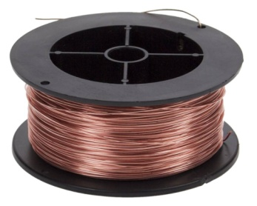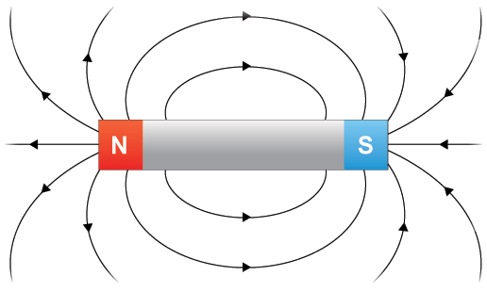
When the wire moves downwards, or the magnet moves upwards, the induced voltage is reversed and the current flows in the opposite direction.
If you reverse the direction of the magnetic field, you will also reverse the direction of the induced voltage and current.
Whenever a magnetic field changes, a voltage is ALWAYS created.
You can control the size of the induced voltage; it is dependent on the rate at which the magnetic field changes:
- If the wire is moved really quickly, then the induced voltage will be higher
- If the wire is moved slowly, the induced voltage will be lower
AC Generators:
In a power station generator, the magnetic field inside the coil is produced by electromagnets. The electromagnetic is made from coils of wire (rotor coils) which are turned by the turbine.
An alternating current is generated in the stator coils which surround the rotor coils.
If you increase the speed at which the electromagnet rotates:
- The current induced in the stator coils will also increase
- The frequency of the generated voltage is also increased
If you increase the number of turns on the electromagnet:
- You increase the magnetic field
- (and as such) induce a larger voltage in the stator coils
Some AC generators have a coil rotating between the poles of a magnet.
As the coil rotates, the direction of the current reverses every half turn to ensure that the coil rotates in the same direction.

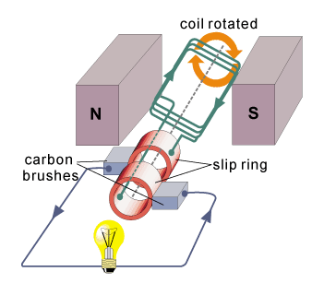
Slip rings are connected to the ends of the coil to allow the coil to spin without winding the wire around itself.
The brushes are contacts that the touch the slip rings to complete the circuit.

Past Papers:
PPQ(1):
PPQ(2):

Mark Schemes:
PPQ(1):
PPQ(2):

