Truth Tables:
When there are several logic gates combined together, truth tables can be used as a simple way to work out what happens within the system; for example:
Input Signals |  |  |  | Output
A | B | C | D | Z
0 | 0 | 0 | 0 | 0
1 | 0 | 1 | 0 | 0
0 | 1 | 1 | 0 | 0
1 | 1 | 1 | 0 | 0
1 | 1 | 1 | 1 | 1
1 | 0 | 1 | 1 | 1
0 | 1 | 1 | 1 | 1
0 | 0 | 0 | 1 | 0
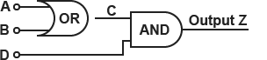

REMEMBER – work step-by-step!
Switching Logic Gates:
Switches, LDR’s and thermistors are all used in a potential divider circuit to give logic gates a high input.
Using the switch as an example, when it is open, he input to the logic gate is low (0).
However, when the switch is closed, the input is connected directly to the 5V supply – here, the input is high (1).
Thermistors and LDR’s work in the same way; just use ideas about resistance rather than it being open or closed.
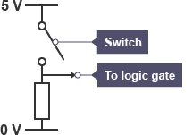

NOTE – if a variable resistor was used in place of a fixed resistor, a threshold level can be set.
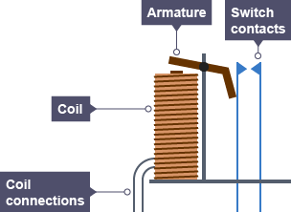
How a Relay Works:
STEP 1 - When a small current passes through a coil, the iron armature is attracted
STEP 2 – the armature pivots and pushes an insulating bar against the central contact
STEP 3 – the central contact moves, opening the normally closed contacts and closing the normally open contacts.

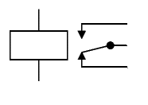
Current output from logic gates is low BUT can be passed through a relay to switch on a larger current needed for motors, heaters etc.
Furthermore, the relay also isolates the logic circuit from the HIGH current to avoid damage to the logic gates.
Normally Closed contacts
Common
Normally open contacts
This represents a coil of wire

Past Papers:
PPQ(1):
Continued on next page...

PPQ(2):
PPQ(3):

PPQ(4):
PPQ(5):
PPQ(6):
Continued on next page...

Mark Schemes:
PPQ(1):
PPQ(2):
PPQ(3):
PPQ(4):
PPQ(5):
PPQ(6):

