Diode Characteristics:
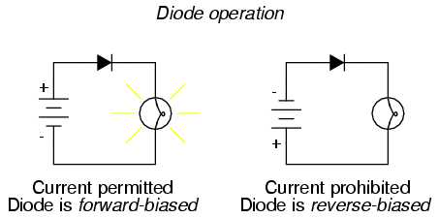
You would set up the diode circuit as you would for a resistor or bulb.
Most diodes need a voltage of 0.6V before they start to work.
When a diode is connected so current can pass (voltage is high enough), it is forward biased.
When a diode is connected so that current CANNOT pass (voltage is too low), it is reverse biased.
An AC supply to a single diode produces a half-wave rectified output.
REMEMBER – AC input means DC output
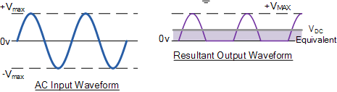
A resistor is always used in series with a diode to protect the diode.
How a Diode Works:
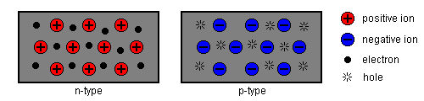
A diode consists of an n-type semiconductor and a p-type semiconductor joined together.
The n-type has an excess of electrons, while the p-type has a shortage of electrons – the gaps are called ‘holes’.
The space either side of the junction (between the two semiconductors) has NO electrons or holes.
If you were going to connect the positive terminal of a power supply to the n-type semiconductor, then the space in the junction would widen and NO current passes.
If you were going to connect the positive terminal of a power supply to the p-type semiconductor, them the space in the junction would narrow, eventually disappear and a current passes.
Rectifier Circuits:
Four diodes can be arranged to make a bridge circuit.
The addition of a capacitor makes the output smoother.
Capacitors:
When a DC supply is connected to a capacitor, the capacitor becomes charged. The voltage across the capacitor increases until it is equal to the supply voltage. However, if the capacitor was connected to a resistor, for example, the voltage decreases as the capacitor discharges.
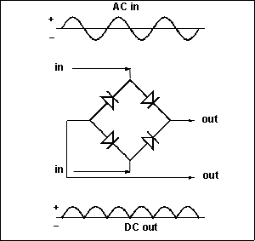
D
C
B
A
Rectification:
In the bridge circuit, during the positive half-cycle, the current passes from A to B to the external circuit, to D then C, then back to the AC supply.
During the negative half-cycle, the current passes from C to B, to the external circuit, to D then A then back to the AC supply.
This makes sure that the DC output is always positive at B and negative at D.
Storing Charge:
The chemicals in a battery continue to produce energy for a battery to use. When the chemicals are all used up, the battery no longer works.
The capacitor stores electrical energy. There is NO continual energy source.
Smoothing:
A smoothing capacitor acts as a reservoir. When the DC voltage from the rectifier circuit falls, the capacitor supplies current to the input. The capacitor charges near the peak value of the varying DC (just as it’s running out of steam).

Past Papers:
PPQ(1):
PPQ(2):
Continued on next page...

PPQ(3):
PPQ(4):
PPQ(5):
Continued on next page...
PPQ(6):
Mark Schemes:
PPQ(1):
PPQ(2):
PPQ(3):
PPQ(4):
PPQ(5):
PPQ(6):

